Using Autograph – Tangents

page-new 2d 24 h p Open Autograph in Standard Level.

axes-edit 24 h p Edit Axes and remove the axes, grid and key (under “Options” tab).

Click the 0.1 Snap Settings.



mode-point 24 h p Draw a point in roughly the middle of the page.

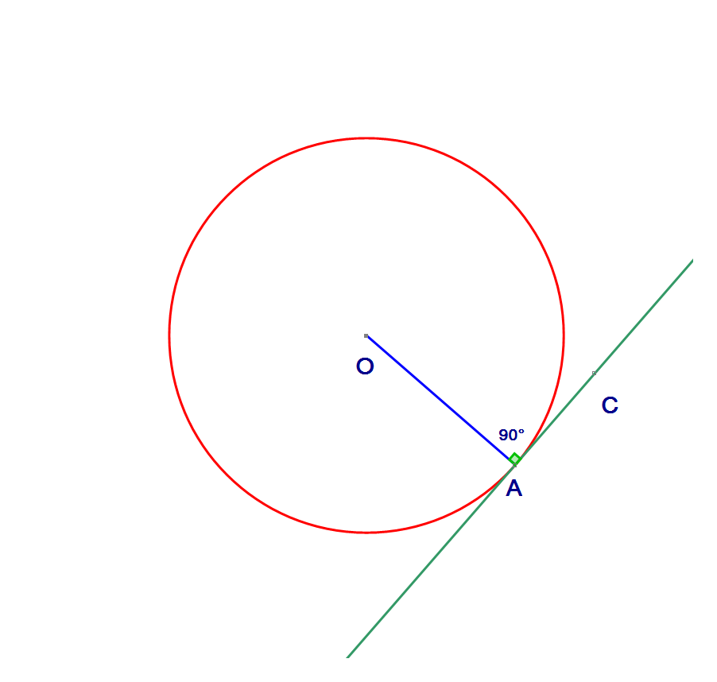 Select the point and right click to add a “Circle (Radius)…”. In the dialogue box give it a radius of 2.5.



Add a point on the circumference of the circle.



Join point A to the centre O by selecting the points, right clicking and choosing “Line Segment”.



Select point A and right click. Select “Tangent” from the drop down menu.



Description: mode-point 24 h p Add a point on the tangent.

Select points O, A, C in that order and right click. Select “Angle…” from the drop down menu, and choose OK on the dialogue box that appears.



Repeat until you can complete the box.

Write ***in your own words*** about the connection between the radius of a circle and the tangent.