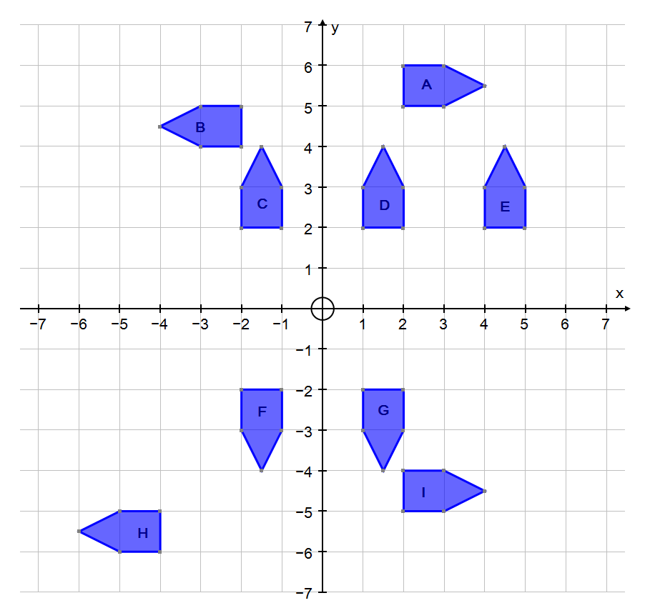
From | To | Transformation | From | To | Transformation

