Using Autograph – Angles in Cyclic Quadrilaterals

page-new 2d 24 h p Open Autograph in Standard Level.

axes-edit 24 h p Edit Axes and remove the axes, grid and key (under “Options” tab).

Click the 0.1 Snap Settings.



mode-point 24 h p Draw a point in roughly the middle of the page.

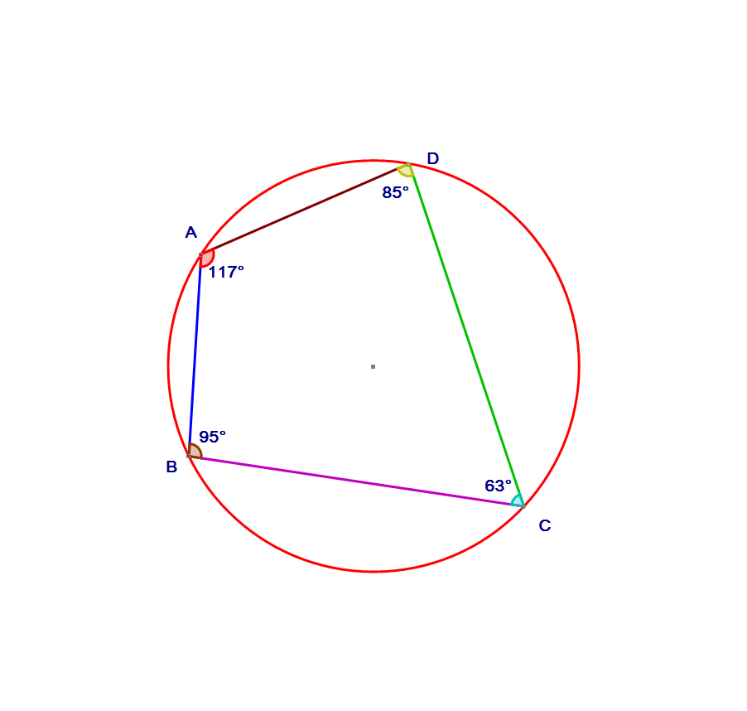 Select the point and right click to add a “Circle (Radius)…”. In the dialogue box give it a radius of 2.5.



Add four points on the circle.



Join point A to point B by selecting the points, right clicking and choosing “Line Segment”. Also join point B to point C, point C to point D and point D to point A. It should look like the diagram.



Select points B, A and D (in that order) and right click to add “Angle…”. Click OK in the dialogue box.  
Now add an angle for ADC, DCB and CBA. Take a note of all angles.



Select any point, and move it to a new position. Again take a note of the angles.



Repeat until you can complete the box.

Write ***in your own words*** about the connection between angles in a cyclic quadrilateral.