Using Autograph – Angle in a Semicircle

page-new 2d 24 h p Open Autograph in Standard Level.

axes-edit 24 h p Edit Axes and remove the axes, grid and key (under “Options” tab).

Click the 0.1 Snap Settings.



mode-point 24 h p Draw a point in roughly the middle of the page.

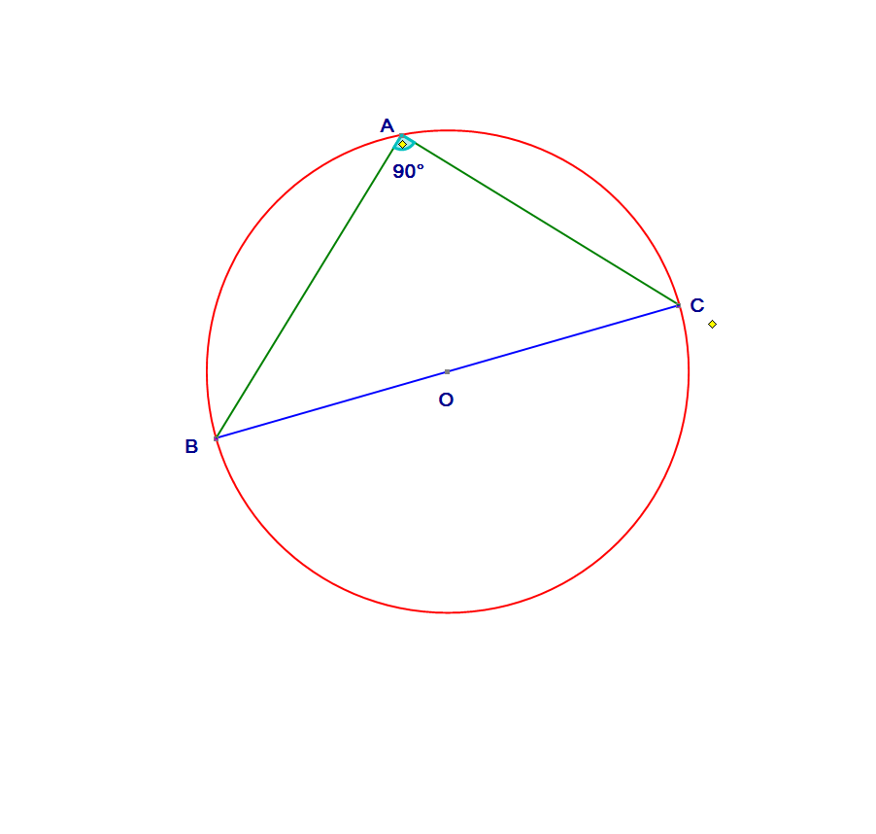 Select the point and right click to add a “Circle (Radius)…”. In the dialogue box give it a radius of 2.5.



Add two points on the circle.



Select points B and O and create a “Straight Line”.



Select the line and circle and “Solve Intersection”.



Place a point on the point of intersection which is not B.



Description: Description: Description: Description: CursorSelect the straight line and “Hide Object”. Select and add “Line Segments” between A and B, A and C and B and C.

Select points B, A and C (in that order) and right click to add “Angle…”. Click OK in the dialogue box.



Select point B to change the diameter or point A, and move it to a new position.



Repeat until you can complete the box.

Write ***in your own words*** about the connection between the angle at the centre of a circle and the angle at the circumference.